**Business Question and Visualization Report**

|  |  |
| --- | --- |
| Date | 03 Oct 2025 |
| Name | Muhammad Yasir |
| Team ID | PNT2022TMIDxxxxxx |
| Project Name | **Power BI Inflation Analysis: Journeying Through Global Economic Terrain** |
| Maximum Marks | 5 Marks |

# Business Questions and Visualisations

The following business questions are framed to extract insights from the **Global Inflation Dataset (1980–2024)**. Each question is mapped with an appropriate visualization type.

### 1. Which countries have experienced the highest average inflation rates over the years?

* **Visualization:** Bar chart comparing average inflation rate by country.
* **Chart: Top 5 countries**

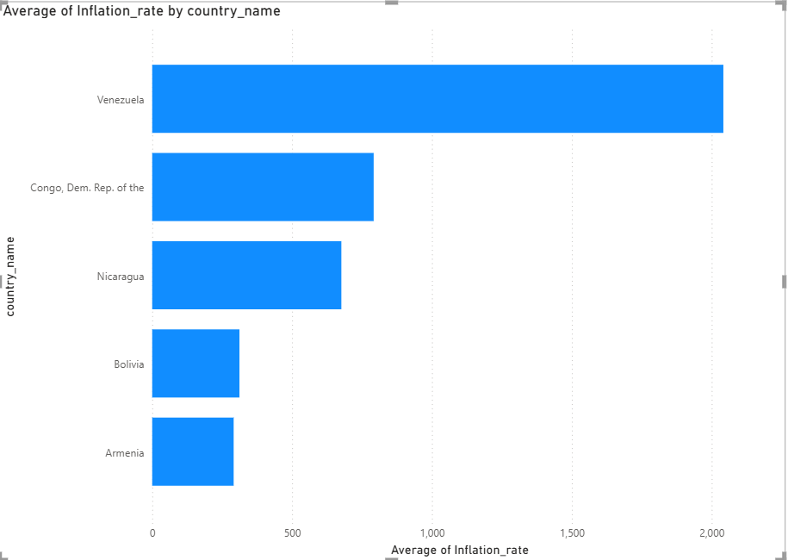

### 2. How have global inflation trends changed from 1980 to 2024?

* **Visualization:** Line chart showing annual global average inflation over time.
* **Chart:**

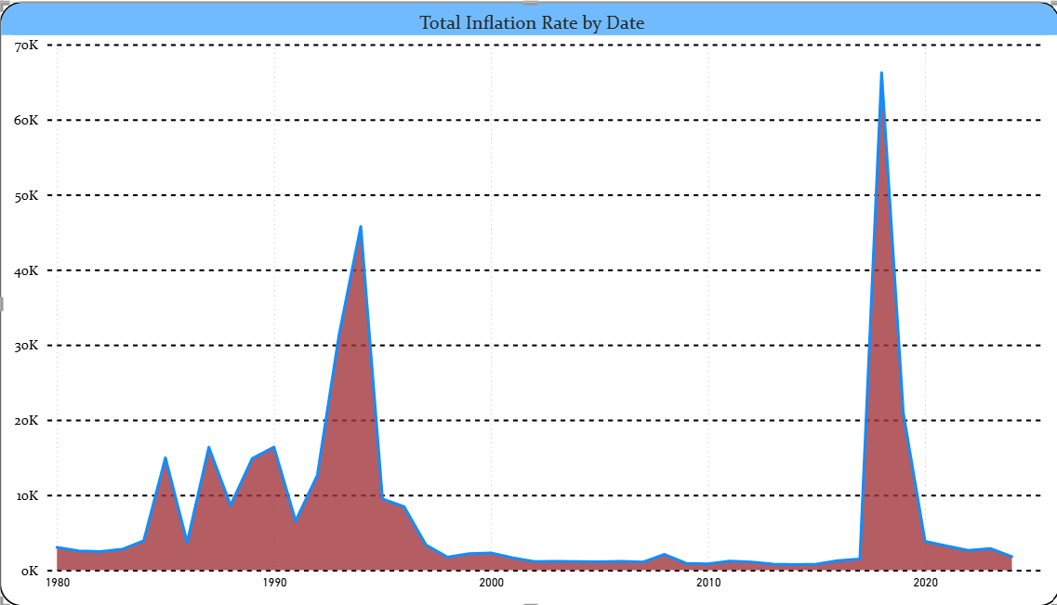

### 3. Which region (Asia, Africa, Europe, etc.) has the highest and lowest inflation trends?

* **Visualization:** Clustered column chart comparing average inflation by region.
* **Chart:**

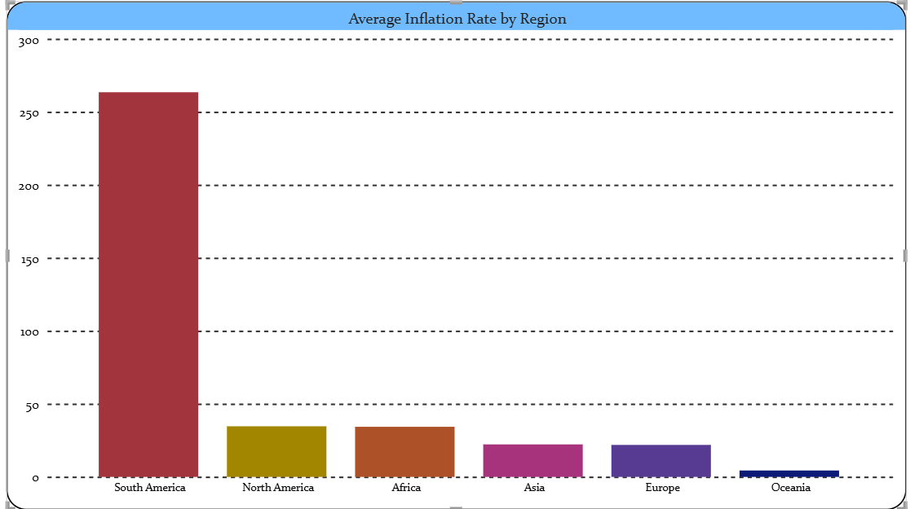

### 4. How does inflation vary across decades (1980s, 1990s, 2000s, 2010s, 2020s)?

* **Visualization:** Line chart or area chart by decade.
* **Chart:**

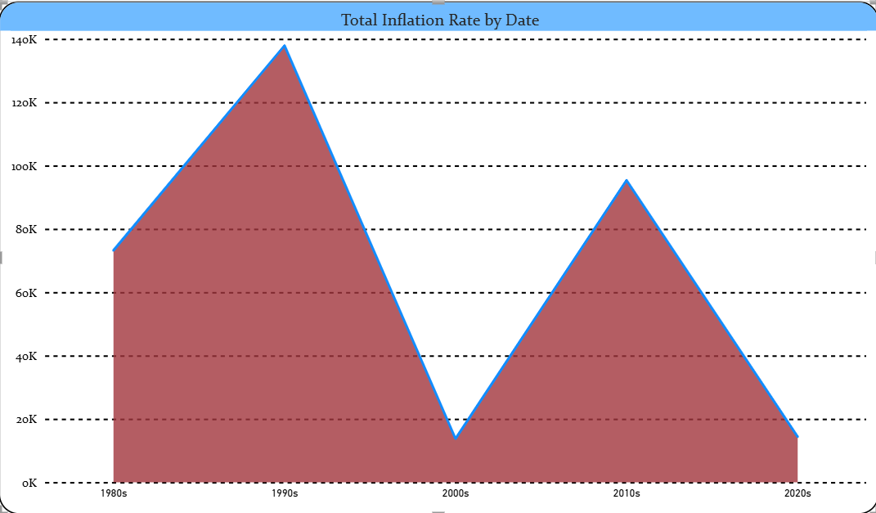

### 5. Which countries have shown the most inflation volatility (large fluctuations)?

* **Visualization:** Bar chart with country OR variance chart.
* **Chart:**

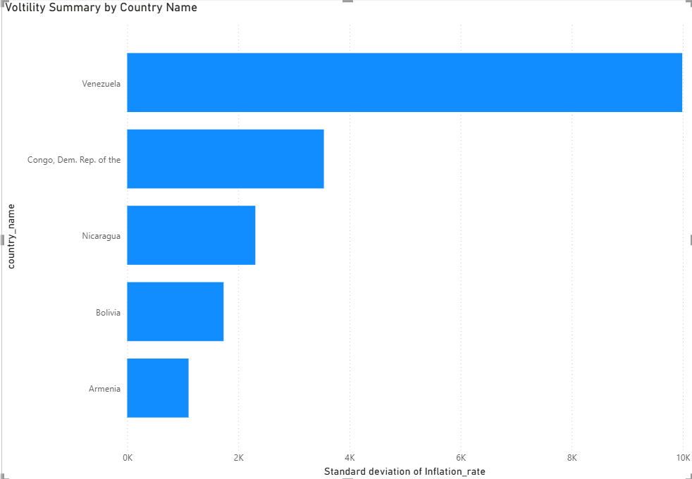

### 6. Which 5 countries had the highest inflation in 2024?

* **Visualization:** Bar chart (Top 5 countries in 2024).
* **Chart:**

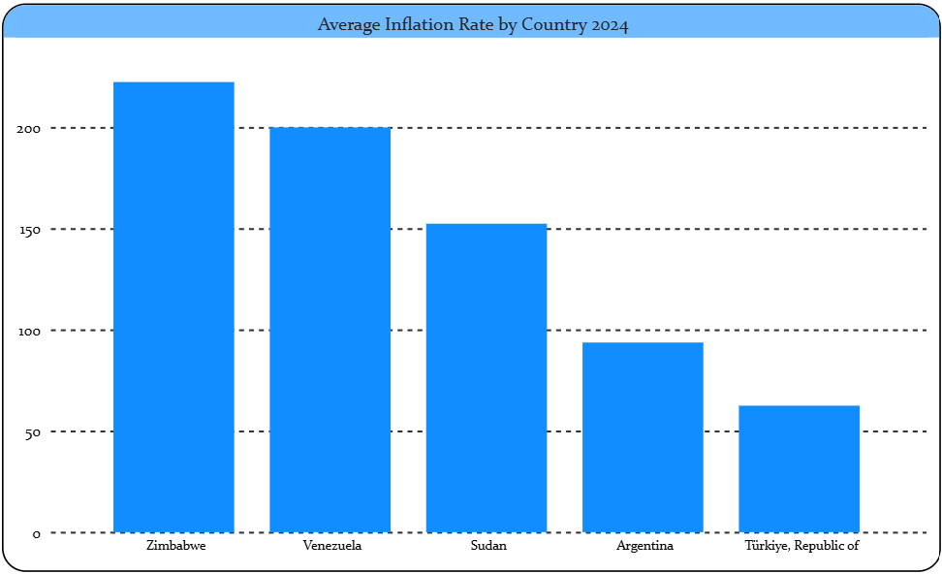

### 7. Which 5 countries had the lowest inflation in 2024?

* **Visualization:** Bar chart (Bottom 5 countries in 2024).
* **Chart:**

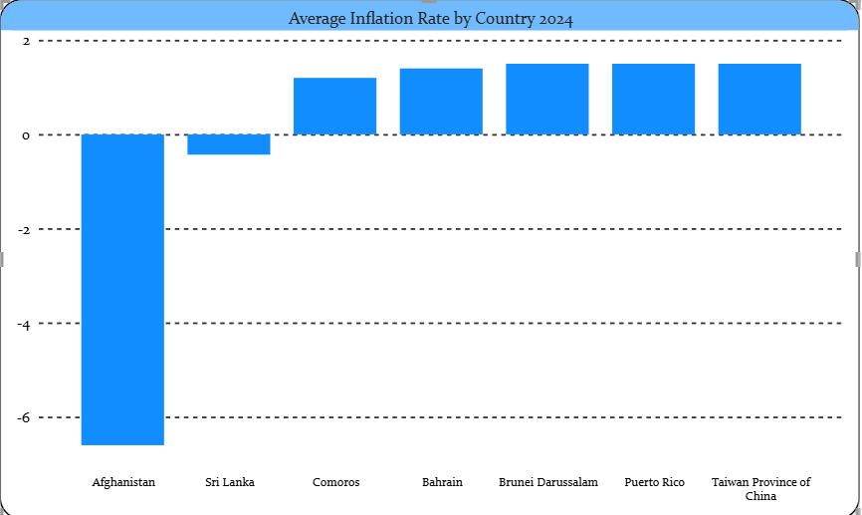

### 8. What is inflation rate distribution by category (high,medium,low)?

* **Visualization:** Pie Chart with inflation rate and cateory.
* **Chart:**

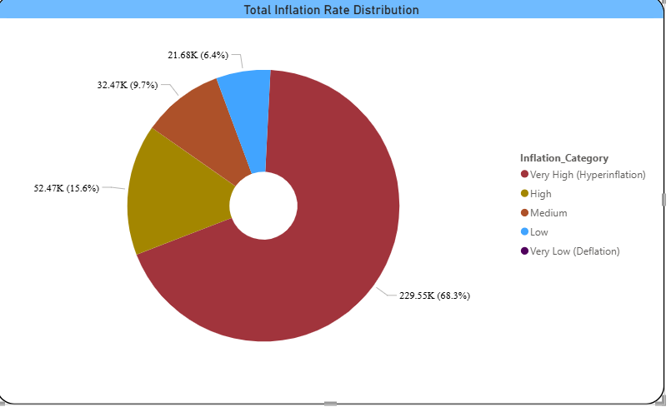

### 9. How is inflation distributed across regions in 2024?

* **Visualization:** Map visualization with color shading (choropleth).
* **Chart:**

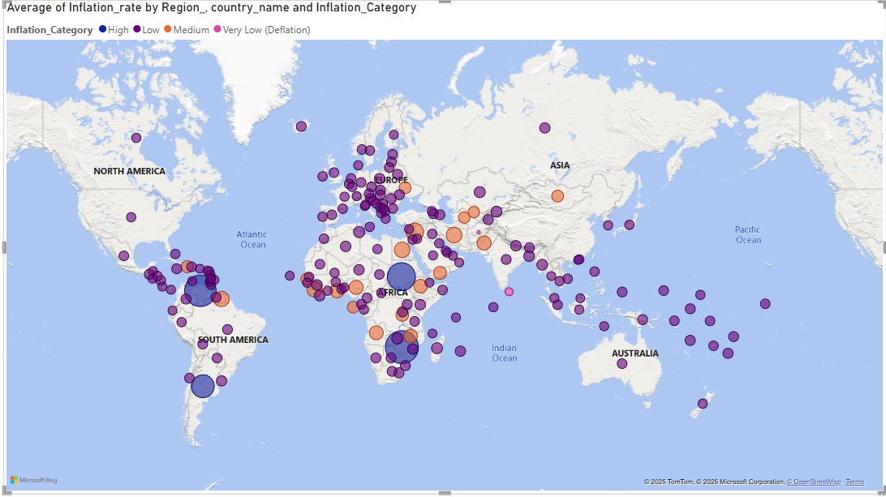

### 10. What is Inflation YoY% change?

* **Visualization:** Card visual(Measure).
* **Chart:**

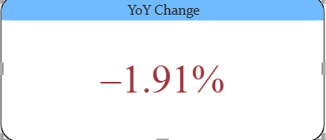

### 14. What is inflation Distribution by decade ?

### ****Visualization:**** Stacked Column by inflation rate with distribution and decade

* **Chart:**

